

ACCREDITATION COUNCIL FOR
PHARMACY EDUCATION
(ACPE)

INTERNATIONAL SERVICES PROGRAM INSTITUTIONAL REPORTING AND EVALUATION SYSTEM (INSPIRES)
USER GUIDE

Version 1.0
03/04/2026

Contents
Introduction: 3
Preparing the INSPIRES Report 4
Program Profile and User Setup 4
Managing My Account 5
Managing Program Contact Information and Users 7
Completing a Program Evaluation 9
Notification of Evaluation 9
Accessing the Evaluation 10
Navigating To Your Assigned Evaluation 11
Viewing the Evaluation Summary 11
Navigating the Program Self-Study Rubric 13
Editing the Program Self-Study 14
Submitting Evidence/Documents 14
Deleting Evidence/Documents 14
Evaluating Key Elements 15
Creating the Narrative 15
Rating the Quality Criteria 16
Entering Recommended Monitoring 17
Submitting the Evaluation/Self-Study 18
Getting Help/Contacting ACPE 20

Introduction:
With the release of the new 2026 International-Accreditation Quality Criteria and corresponding rubric, the decision was made to develop an online platform, managed by ACPE, for international colleges and schools to create, manage, and submit their program’s self-study report via any common web browser.
The International Services Program Institutional Reporting and Evaluation System (INSPIRES) is designed to assist an international college or school in preparation of its self-study report and document how its program is addressing ACPE’s International-Accreditation Quality Criteria. The platform specifically identifies the documents, data, and narrative text that should be provided by the college or school for evaluation of the program’s compliance with each of the quality criteria.
The process works as follows:
- ACPE will be adding the college or school dean to the INSPIRES system. The Dean will have an account created using their email address as the username. The Dean will be able to add additional users to the INSPIRES system, if needed.
- When the program is scheduled for a Comprehensive Review, the individual(s) granted access will receive an email from ACPE indicating that the platform is ready for the self-study to be entered.
- The college or school will then be able to access INSPIRES via a web browser and begin the process of writing the self-study, evaluating the program, submitting documentation, and providing a narrative.
PLEASE NOTE: ACPE and evaluation team members will NOT have access to the self-study report content UNTIL the international college or school has completed every section of the rubric, all required documentation has been uploaded, all narratives have been entered, AND the college or school has attested to the completeness and accuracy of the information provided.

Preparing the INSPIRES Report

Program Profile and User Setup

ACPE staff responsible for the management of international college or school accreditation history will manage the initial configuration of the program profile. Once the program profile has been created, the Dean will be entered as a user under the program profile and an email will be sent from the system with login information. The recipient’s email address will be the User ID when accessing the system. A sample email is included below Figure 1.
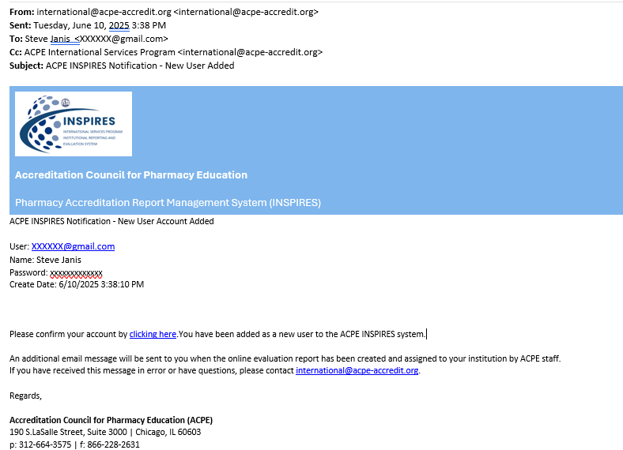
Figure 1: Figure 1: INSPIRES User Creation Email

The user should confirm their account, login, and review their account profile information. The user may make any necessary profile changes as needed.
Note - Password requirements:
- Must have at least one uppercase ('A'-'Z')
- Must have at least one lowercase ('a'-'z')
- Must have at least one non alphanumeric character
- Must be at least 8 characters long.

Managing My Account
By clicking on the email address on the right-hand side of the menu bar, the user may edit their personal account information.

Figure 2: Menu Bar - Access My Account

After clicking the email address – the user is taken to the “Manage your account” page.
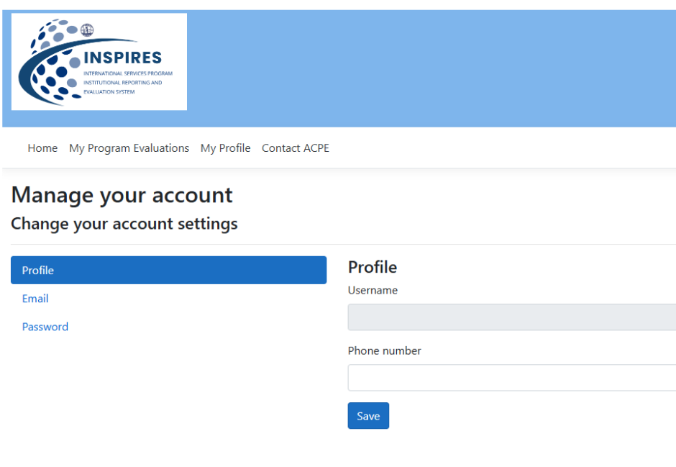
Figure 3: Manage your account - Profile

On the Manage your account page – you are able to:
- Update/set your phone number
- Update/set your email address
- Change your password.
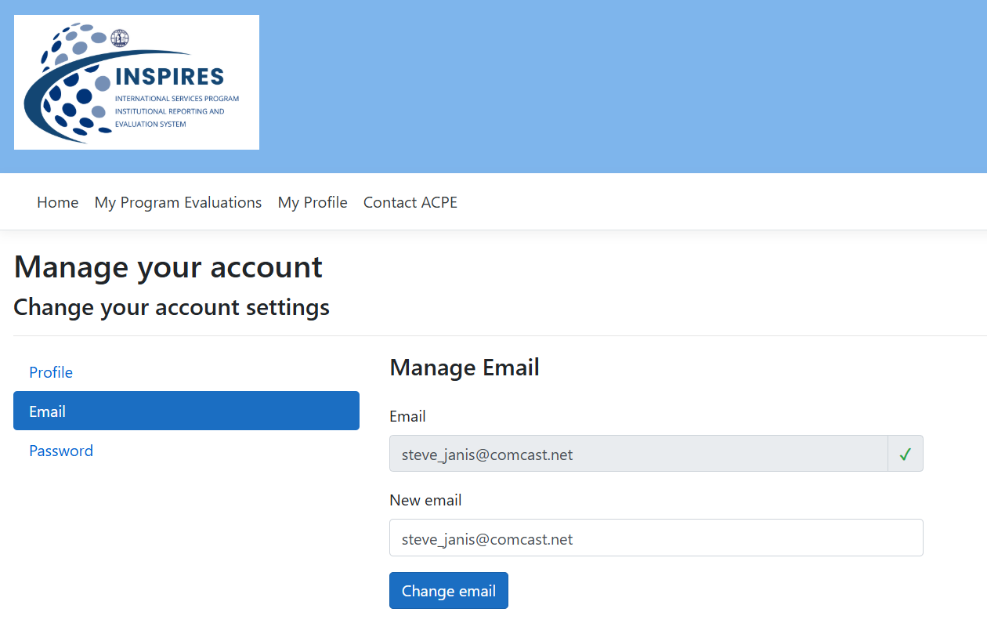
Figure 4: Manage your account - Email

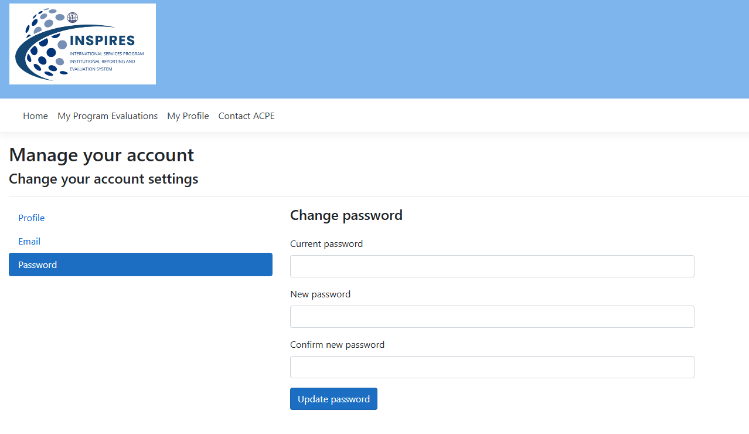
Figure 5: Manage your account - Change Password

Managing Program Contact Information and Users

You will be able to manage the program contact information and grant access to additional users that may view and edit the program being evaluated. You can do this by accessing the “My Profile” link on the main menu.
Figure 6: My Profile Link

On the Edit College/School page, you can edit and save general contact information for the college/school:
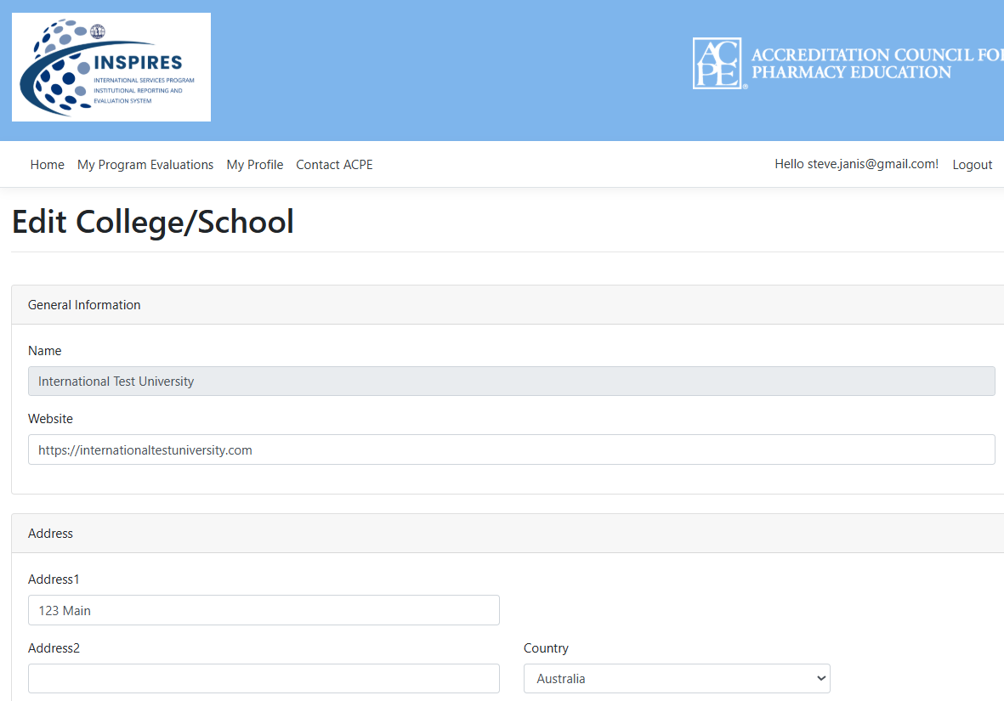
Figure 7: Edit a program profile
On this page additional users can be created to access and edit the program evaluation (self-study). Scroll to the bottom of the page and there will be a user listing.
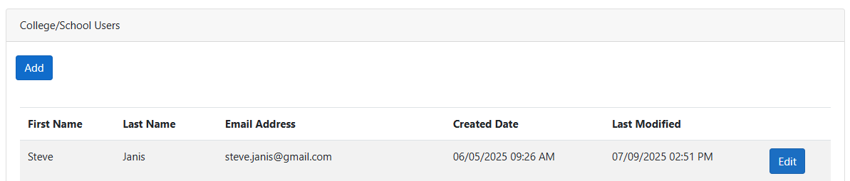
Figure 8: User management

By clicking the “Add” button, additional users can be added. You may also edit existing users using the “Edit” button.
Simply fill in the required information and set a default password for the user. The new user will be notified via email that an account has been created in the INSPIRES system. The user will be able to change their password after verifying their email and performing an initial login.
The Dean will be defaulted as the user required to submit the report. If you wish to designate another user to submit the report, please check the “Can Submit Report to ACPE” checkbox on the user profile you are creating or editing.
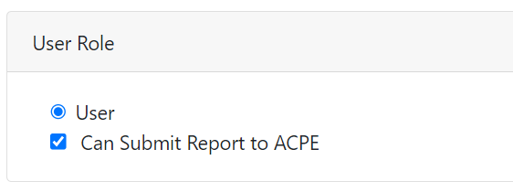
Figure 9: "Can Submit Report to ACPE" permission

Completing a Program Evaluation

Notification of Evaluation
When the program is scheduled for a Comprehensive Review, the individual(s) granted access will receive an email from ACPE indicating that the platform is ready for the self-study to be entered.
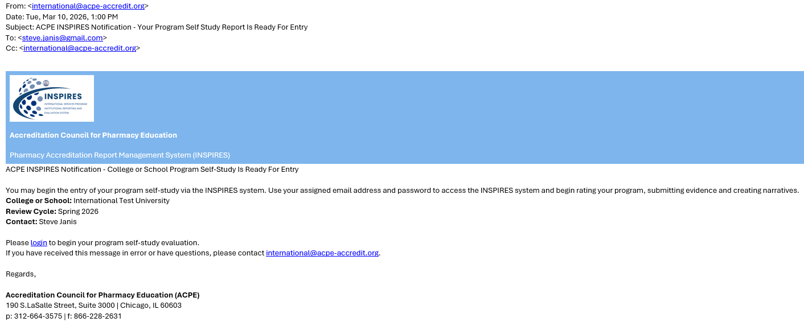
Figure 10: Notificaton of Report Ready for Entry

The email will contain a hyperlink that will take you to the INSPIRES Log In page.

Accessing the Evaluation
The user will be able to use their email address and password to login to the INSPIRES system which is located at https://inspires.acpe-accredit.org
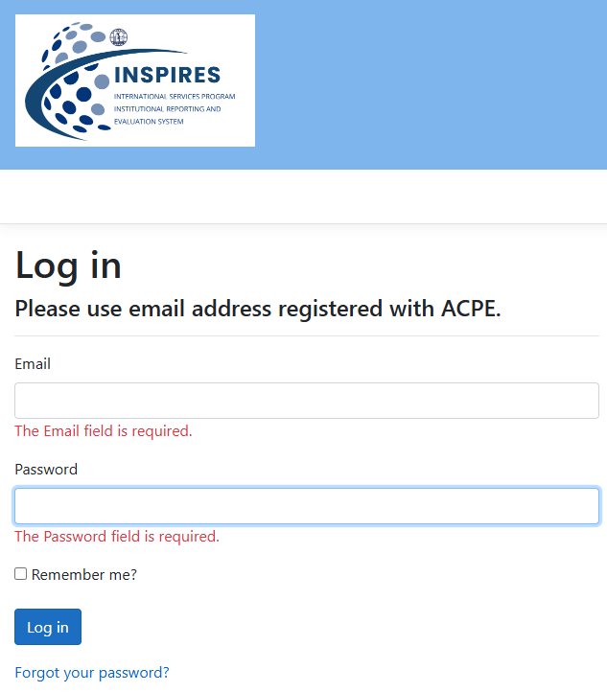
Figure 11: Login Page
Upon successful login, the user will be re-directed to the Home page of INSPIRES.

Figure 12: INSPIRES Home Page

Navigating To Your Assigned Evaluation
To begin your program evaluation – click the “My Program Evaluation” menu item. This will take you to the program evaluation listing.
Figure 13: My Program Evaluation Menu
A screen showing the assigned evaluation will appear.
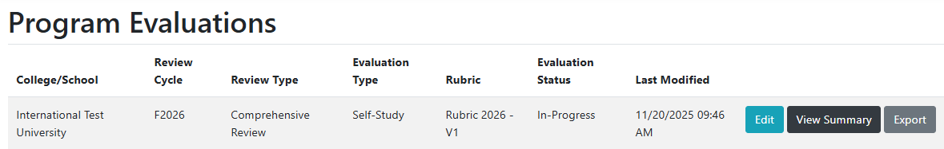
Figure 14: My Program Evaluations List

The following action will appear:
- Edit – this will open the first section of the evaluation report assigned.
- View Summary – this will open a summary view of the evaluation report.
- Export – this will generate a compressed file (ZIP format) containing a PDF version of the report. The compressed file will also include all the submitted documentation associated with the report. Note – the PDF version of the export will reference the local files contained within the zip folder. To access the report and its content, it is best to unzip the contents.

Viewing the Evaluation Summary
When you click on the “View Summary” button on the “My Program Evaluations” listing page, you are taken to the Program Self-Study Summary. The evaluation summary view contains the following information:
- Shows all the Quality Criteria and the selected compliance rating.
- Shows the sub-components of the Quality Criteria and their status of completion. The statuses are:
  - Not Started – the Quality Criteria sub-component has not yet been modified in any way.
  - In-Progress – documentation was provided, a key element rating was assigned, and/or a narrative was provided.
  - Complete – all required elements of the Quality Criteria sub-component were selected, uploaded, or entered by the user.
- Shows the lowest rating selected for any of the key elements of the Quality Criteria sub-component.
- Allows for navigation to a specific Quality Criteria sub-component of the rubric.
- Allows for printing of the summary page only.
- Allows for printing of the full self-study report.

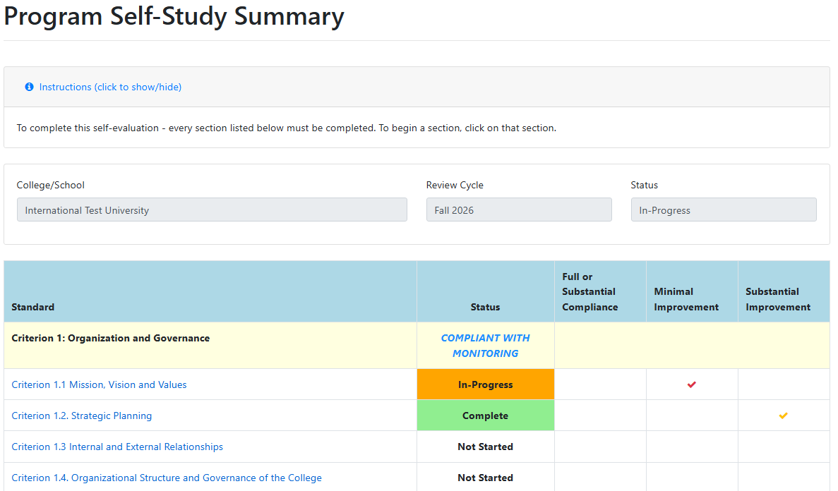
Figure 15: Evaluation Summary
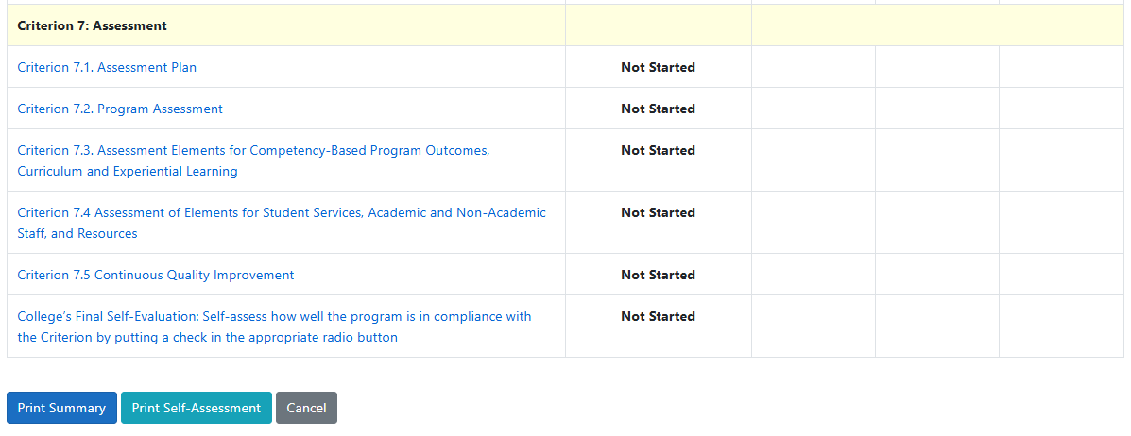
Figure 16: Evaluation Summary Print Options

Navigating the Program Self-Study Rubric
When you click on “Edit” from the “My Program Evaluations” listing or choose a Quality Criteria sub-component from the Evaluation Summary page, you will be taken to the edit page. Navigation buttons can be found at both the top and bottom of the page.
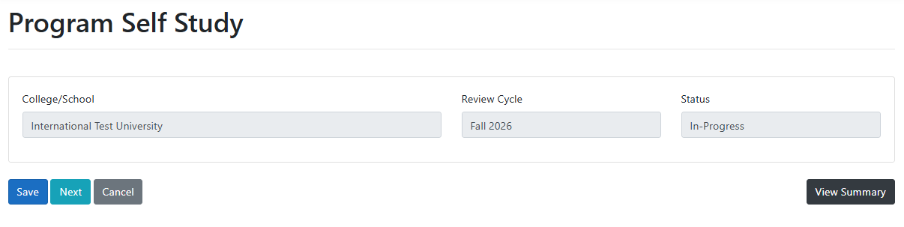
Figure 17: Program Quality Criteria Sub-component Navigation
- Save – will save any changes you have made.
- Previous – will take you to the previous section in the rubric. (Note – this button will hide when you reach the beginning of the evaluation report).
- Next – will take you to the next section in the rubric. (Note – this button will hide when you reach the end of the evaluation report).
- Cancel – will take you to the “Program Summary” page.
- View Summary – will take you to the “Program Summary” page.

Editing the Program Self-Study
There are 5 key sections to each Quality Criteria that must be completed by the international college or school.
- Report Documentation and Data evidence relevant to the Quality Criteria.
- Key Elements related to the Quality Criteria sub-component. There are more than one sub-component per Quality Criteria.
- Descriptive text addressing specific statements for the Quality Criteria. This is the narrative.
- An overall compliance rating for the Quality Criteria.
- Recommended monitoring (this is optional for Quality Criteria rated as compliant).
Submitting Evidence/Documents
Each Quality Criteria requires specific evidence/documents to be submitted in order for the rubric Quality Criteria to be marked “Complete.” A description of the required documentation and data is listed on the left side of the page. To upload documentation, click the “Choose Files” button to upload a document that will be included in your report. After uploading – be sure to select the file that corresponds to the required documentation and/or data requested.

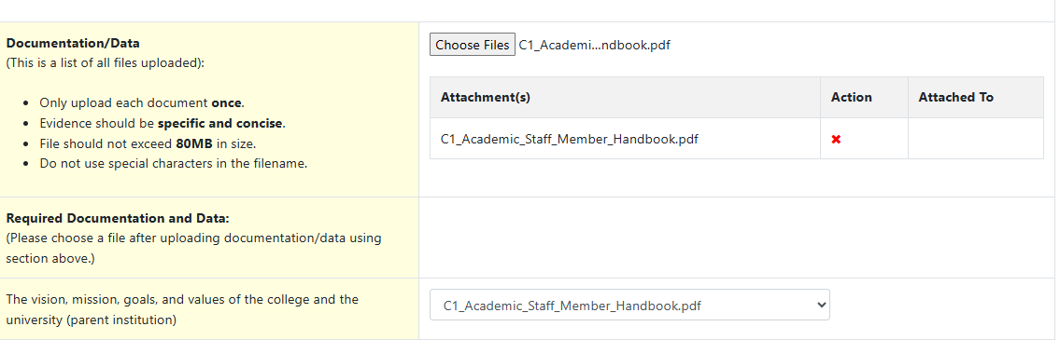
Figure 18: Report Documentation and Data Evidence
Deleting Evidence/Documents
To delete documents previously submitted, make sure to detach the file from all the sections that it may be associated with.
- Go to the section where the file has been attached/previously selected.
- Deselect the file by choosing another file or selecting “<** Choose a file **>.”
- Press save button. The file will have been detached.
- A red “X” will now appear next to the file in the file listing.
- Click on the red “X” to delete the file from the file listing.
- Finally, click on “Save” to persist the changes.

Evaluating Key Elements
Each sub-component of the Quality Criteria will have a list of key elements to be evaluated. The key elements must be assigned one of the following ratings:
- Full or Substantial Compliance
- Minimal Improvement
- Substantial Improvement
In order for the sub-component to be marked completed, each key element must have a rating assigned.
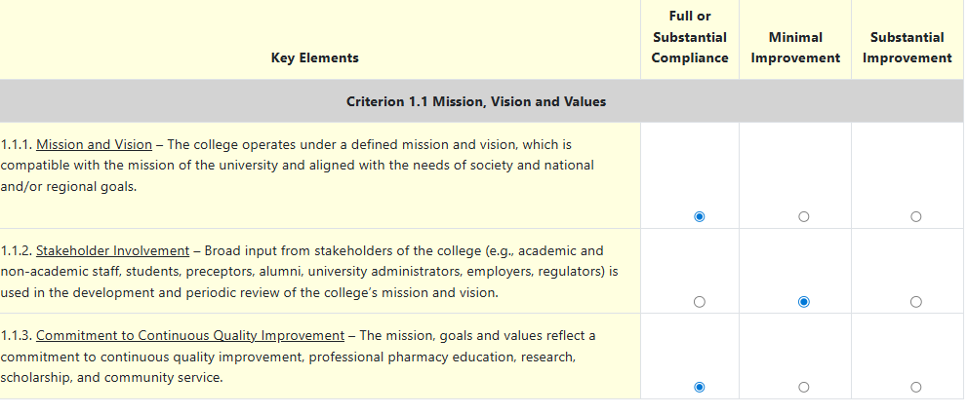
Figure 19: Quality Criteria Sub-Component Key Elements

Creating the Narrative
Each Quality Criteria will contain a section where the international college or school must provide description text to address specific statements related to the Quality Criteria. The narrative text editor is an editor that supports basic formatting options such as bold, italics, underline, indenting, justification, etc.
Each narrative will have a maximum character limit that varies per Quality Criteria. If you should exceed the maximum character limit, a warning will appear, and you will not be able save your changes until you are under the maximum limit.
Please note that you may:
- Copy content from a Word document and paste it into the narrative text editor.
- Copy and paste tables from Excel or Word into the narrative text editor.
- Paste images into the narrative text editor.
In order for the Quality Criteria to be marked completed, a narrative must be provided.
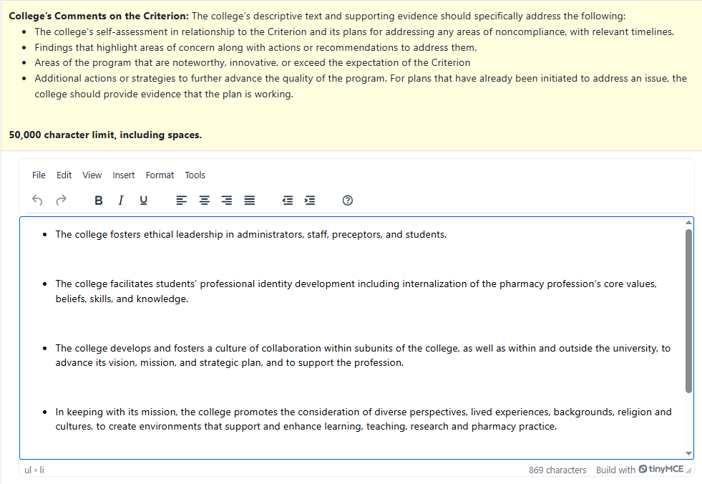
Figure 20: Descriptive Text Addressing Statements Related To Quality Criteria

Rating the Quality Criteria
The last section of each Quality Criteria requires the selection of a compliance rating. For each Quality Criteria, the user will be required to choose one of the following ratings:
- Compliant
- Compliant with Monitoring
- Partially Compliant
- Non-Compliant
In order for the Quality Criteria to be marked completed, a compliance rating must be assigned.
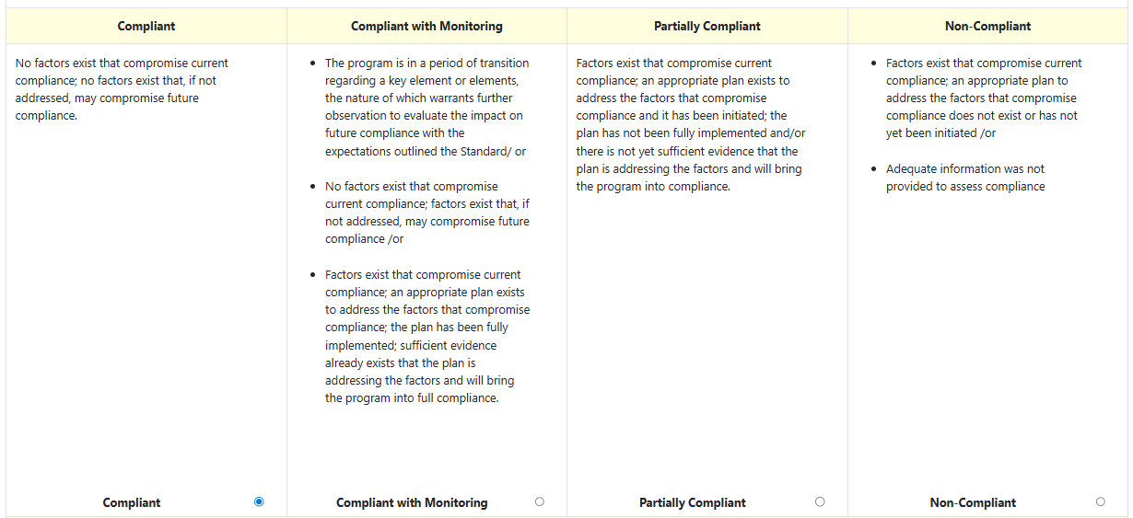
Figure 21: Compliance Rating for Quality Criteria

Entering Recommended Monitoring
Each Quality Criteria will contain a section where the international college or school may provide a description of issues or elements that may require further monitoring within the Quality Criteria being evaluated. The narrative text editor is an editor that supports basic formatting options such as bold, italics, underline, indenting, justification, etc.
Recommended Monitoring has a maximum character limit. If you should exceed the maximum character limit, a warning will appear and you will not be able save your changes until you are under the maximum limit.
Please note that you may:
- Copy content from a Word document and paste it into the narrative text editor.
- Copy and paste tables from Excel or Word into the narrative text editor.
- Paste images into the narrative text editor.
This section is optional if the Quality Criteria is rated Compliant.
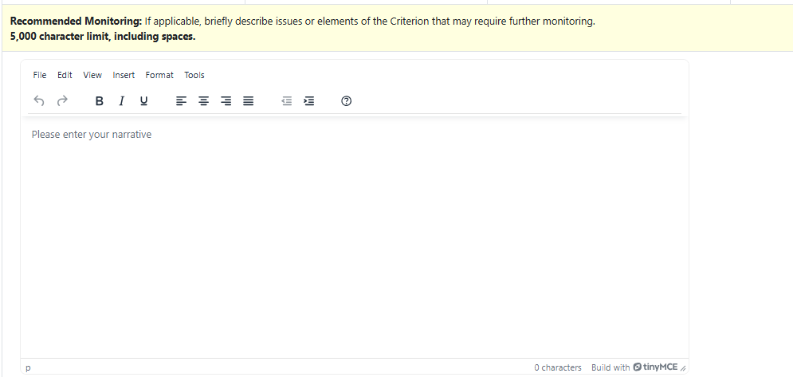
Figure 22: Recommended Monitoring

Submitting the Evaluation/Self-Study
To submit the self-study, all required data elements must be provided in each section of the rubric. Once all the Quality Criteria’s sub-components have been moved to a “Complete” status, an attestation box will appear at the bottom of the Program Self-Study Summary page.

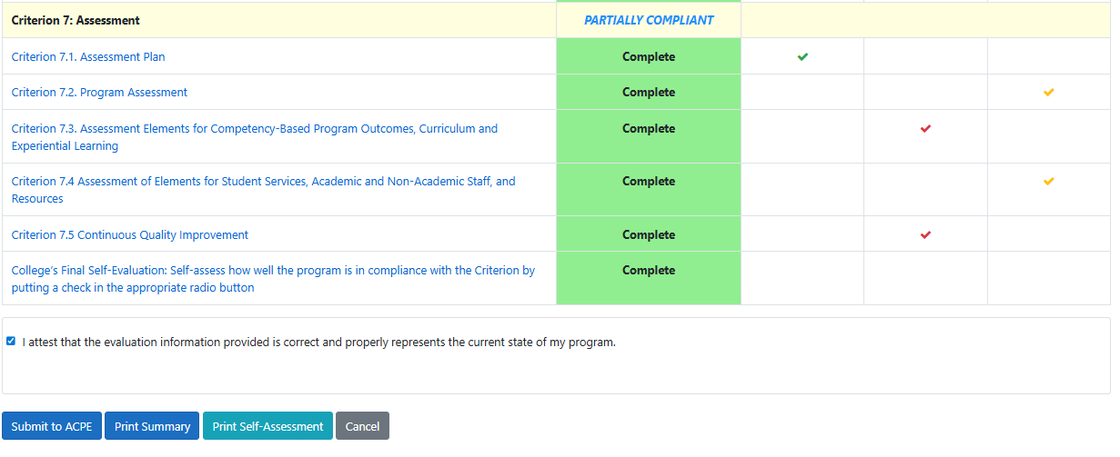
Figure 23: Attestation Statement

The self-study must be attested by a user assigned as a submitter for the international college or school. By checking the box, the submitter attests the report is complete. Once attested, a system-generated email is sent to the submitter and to ACPE staff.
Once submitted – no further edits will be allowed by the college or school. Please make sure your report is complete and contains the correct documentation prior to attesting and submitting the report.

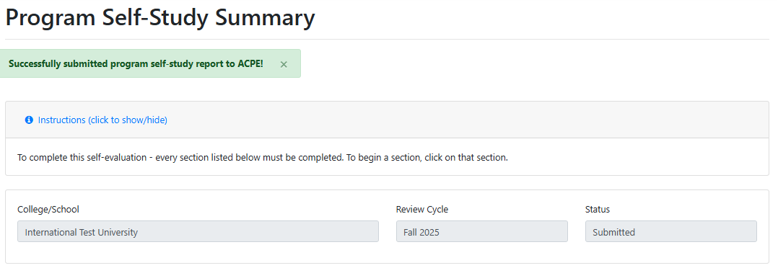
Figure 24: Successful Report Submission

Getting Help/Contacting ACPE
For any questions you may have or issues you encounter – please contact ACPE by either emailing international@acpe-accredit.org or using the “Contact ACPE” menu option in INSPIRES.
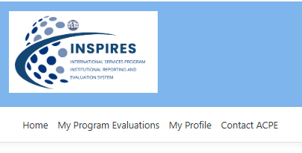
This will send you to the Contact ACPE web page. Here you can enter a subject and a description of your question or issue and then click “Submit” to send your request to ACPE’s International Service Program general information inbox (international@acpe-accredit.org). A copy will be also sent to the user.
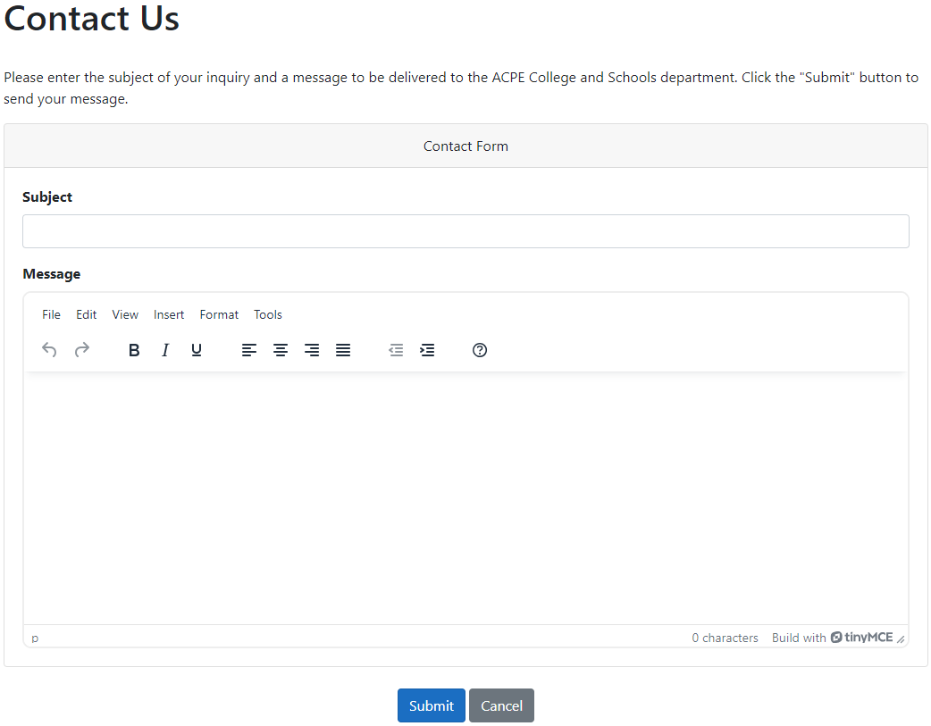
Figure 25: Contact ACPE Form

